Playwright + AI Mastery - Notes - 2x
﻿

Javascript Basics
- What is Javascript?
- How JavaScript Engine Works
- How does a V8 engine Works?
- Setup IDE Antigravity / VS code
- AI Coding - OpenCode. / Github Copilot Setup.
- Github Account
﻿

What is Javascript?
- A website is built with three core technologies
  - HTML — Structure / Content
  - CSS — Styling / Appearance
  - JavaScript — Behavior / Interactivity
- Where it runs: Originally designed to run in web browsers, JavaScript now also runs on servers (via Node.js), mobile apps, desktop applications, and even IoT devices.
- Core features: It supports object-oriented, functional, and event-driven programming styles. It's dynamically typed, meaning you don't need to declare variable types explicitly.
- The DOM: JavaScript can manipulate the Document Object Model (DOM), allowing it to dynamically change a webpage's content, structure, and styling in real time without reloading.
- Asynchronous programming: It supports asynchronous operations through callbacks, Promises, and `async/await`, making it efficient for tasks like API calls and file handling.
- Ecosystem: It has a massive ecosystem of libraries and frameworks such as React, Angular, Vue.js (frontend) and Express, Next.js (backend), supported by the npm package manager.
- Universal adoption: JavaScript is the most widely used programming language in the world, supported by all modern browsers and backed by a huge developer community.
﻿
int a = 10; - data type
In JS -> let a = 10;
﻿
﻿
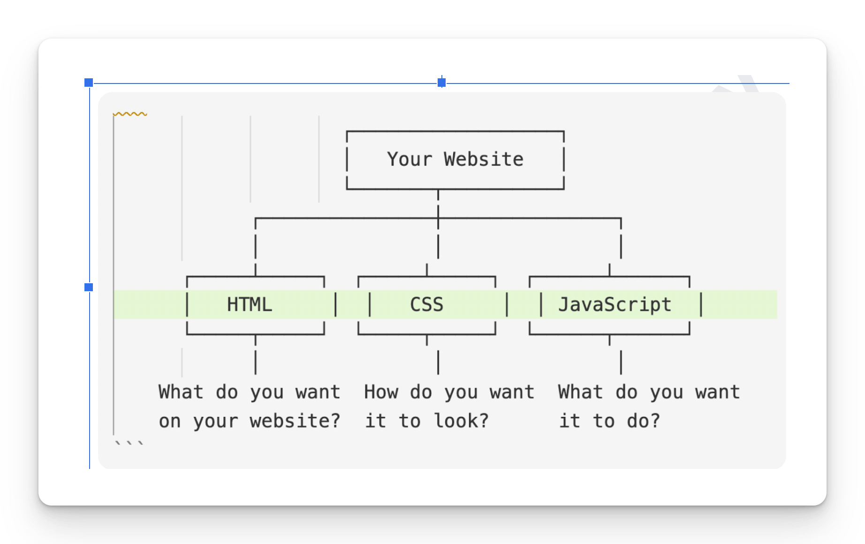

﻿

✅ Is JavaScript Compiled or Interpreted?
﻿
﻿
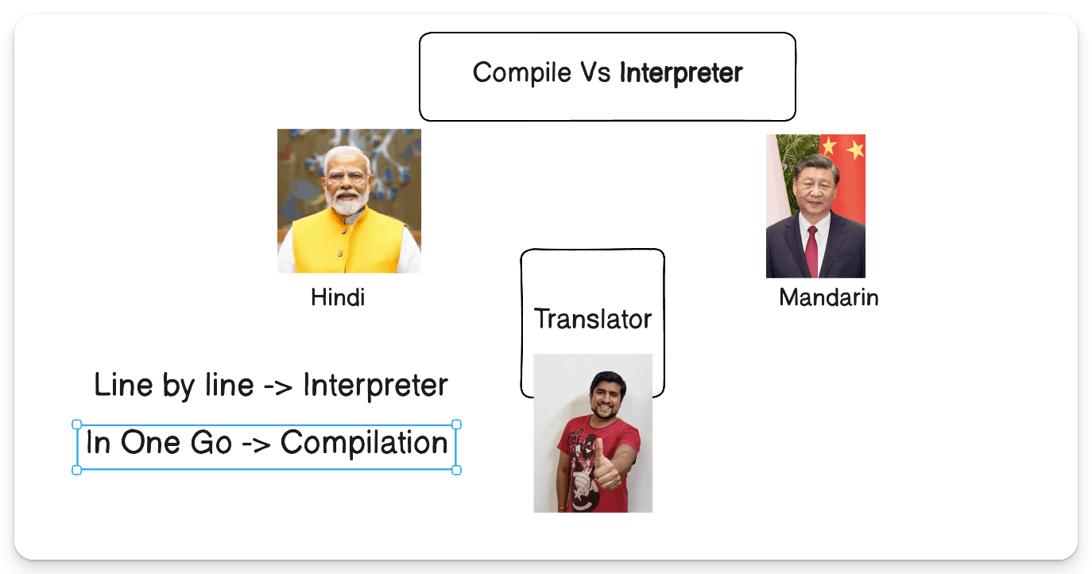
﻿
﻿
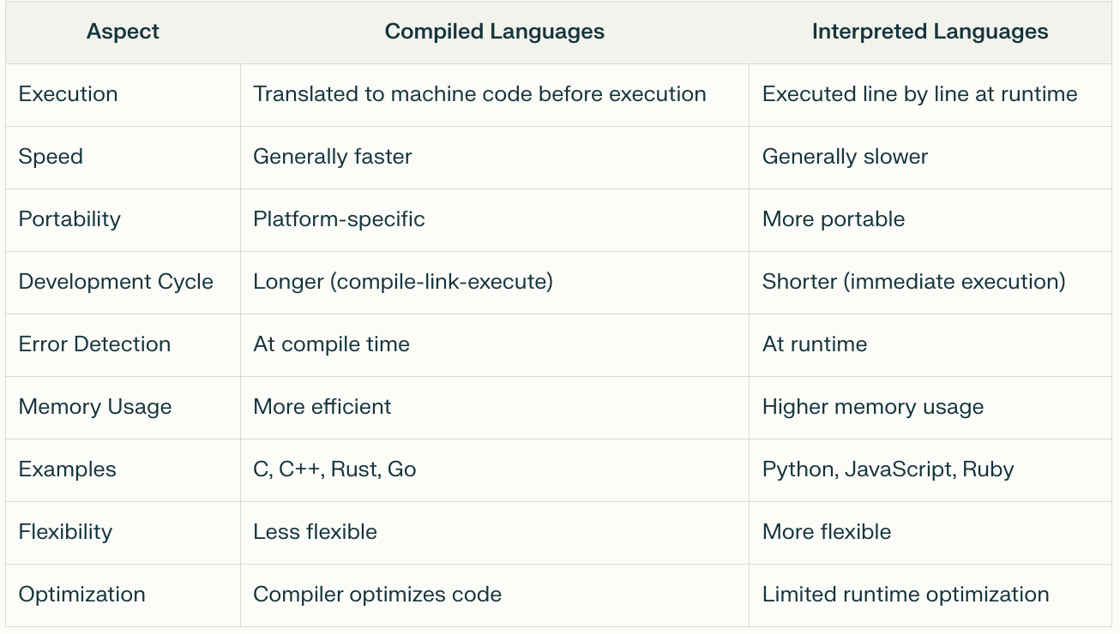
﻿
✅ JavaScript: Compile-Time & Runtime?
- JavaScript is Primarily a Runtime (Interpreted) Language Traditionally, JavaScript code is executed line by line at runtime by the browser's JS engine.
- Simple Terms - JavaScript is a runtime language that uses JIT compilation internally for performance.
﻿
JavaScript is an interpreted language with JIT compilation at runtime.
Just in time
﻿
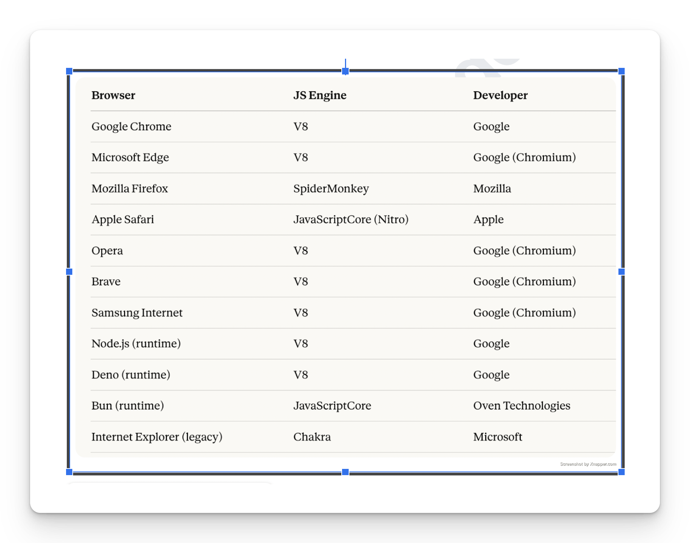
Computer - Machine Code
﻿
Write Javascript -> How it will run on the Browser?
JS Engine
﻿
V8 Engine (Presnet Browsers)
﻿﻿v8.dev/
V8 is Google’s open source high-performance JavaScript and WebAssembly engine, written in C++.
﻿
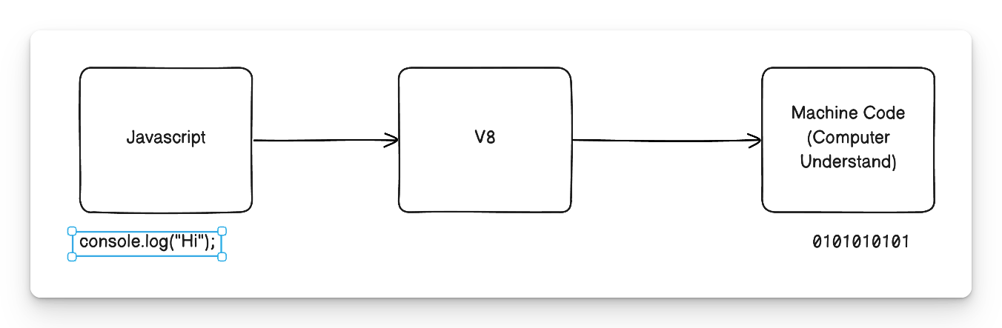
✅ What is ﻿Node.js?
- Node.js is an open-source, cross-platform JavaScript runtime environment that allows you to run JavaScript code outside of a web browser primarily on servers.
- It was created by Ryan Dahl in 2009 and is built on Google Chrome's V8 JavaScript engine.
- Node.js® is a free, open-source, cross-platform JavaScript runtime environment that lets developers create servers, web apps, command line tools and scripts.
﻿
﻿
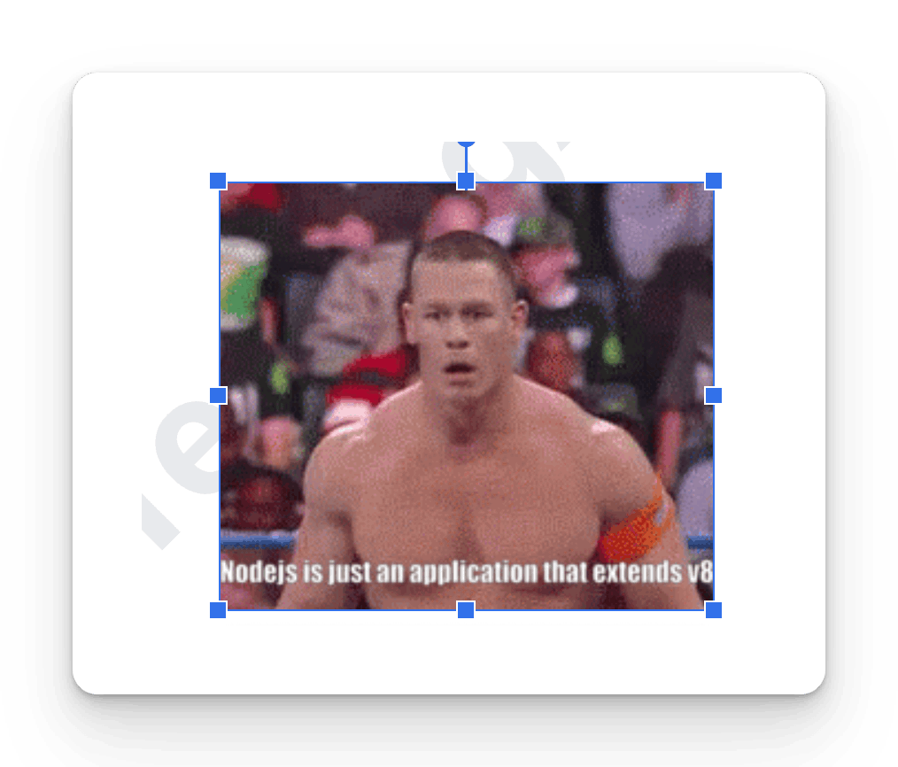
﻿
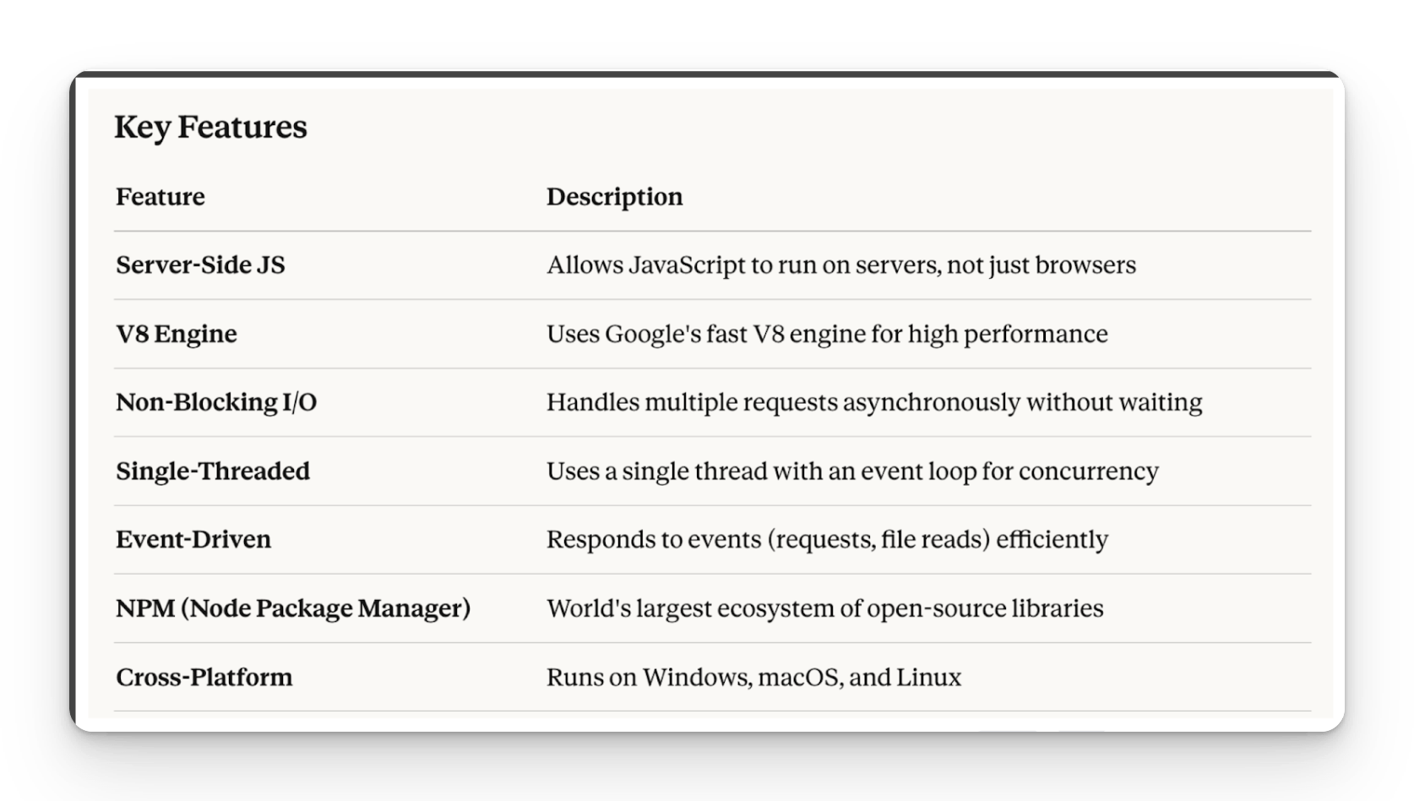
Common Use Cases
- Web Servers & APIs (REST, GraphQL)
- Real-Time Apps (Chat apps, live notifications)
- Microservices Architecture
- Command-Line Tools (CLI apps)
- Streaming Applications (Video/audio)
- IoT (Internet of Things)
- Mobile Apps
﻿
﻿
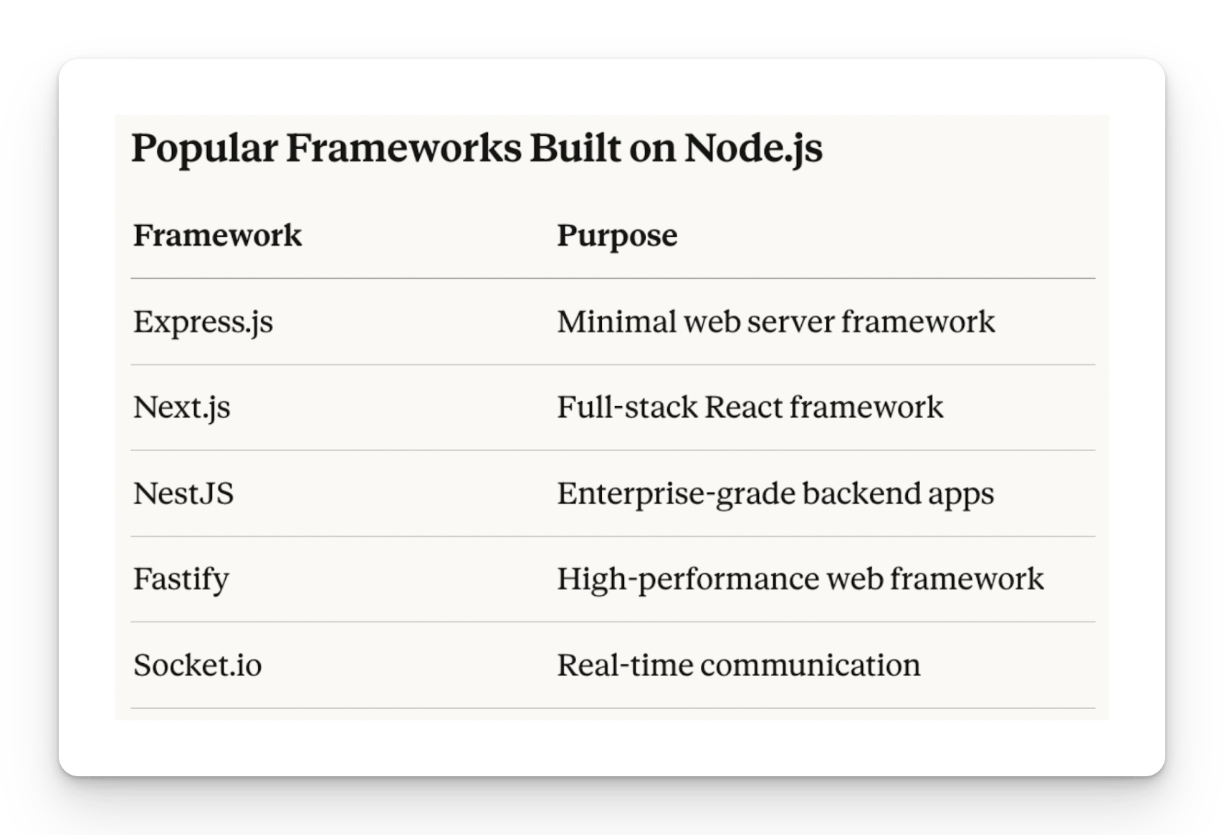
JavaScript environment is very Big, JavaScript has the most libraries, utilities, and frameworks available compared to any other programming language.
﻿

🟩 NODE js in simple terms
Node.js = JavaScript + V8 Engine + Server-Side Capabilities, enabling full-stack development using a single language.
﻿
JS (Javascript)-> TS(Typescript) -> Playwright (TS)
Javascript has nothing to do with JAVA
﻿
﻿

How do I write my JavaScript code?
- NotePad
- IDE ( Integrated Development Environment )
  - Visual Studio Code
  - Antigravity - Google
  - Cursor AI
  - WindSurf
  - Eclipse JS
  - Web Storm - JetBrain
﻿
Company Laptop
- Visual Studio Code (Open source FREE, allowd in the 99.9% Copanies)
﻿
Personal
- Visual Studio Code
- Antigravity Google
﻿
Very Rich (Purchase)
- Cursor AI, Windsurf.
- Web Storm
- Codex
- Claude Code
﻿

🟩 Install Visual Studio Code
﻿﻿code.visualstudio.com/download
﻿
Option 1 : Visual Studio Code + Github Coplit ( Company Has given ) - Please use this
Option 2 : Visual Studio Code + OpenCode ( Go Subscrition first Month 484 Rs) per month - Kimi k2.6 -~ Claude Opus 4.5
﻿
﻿
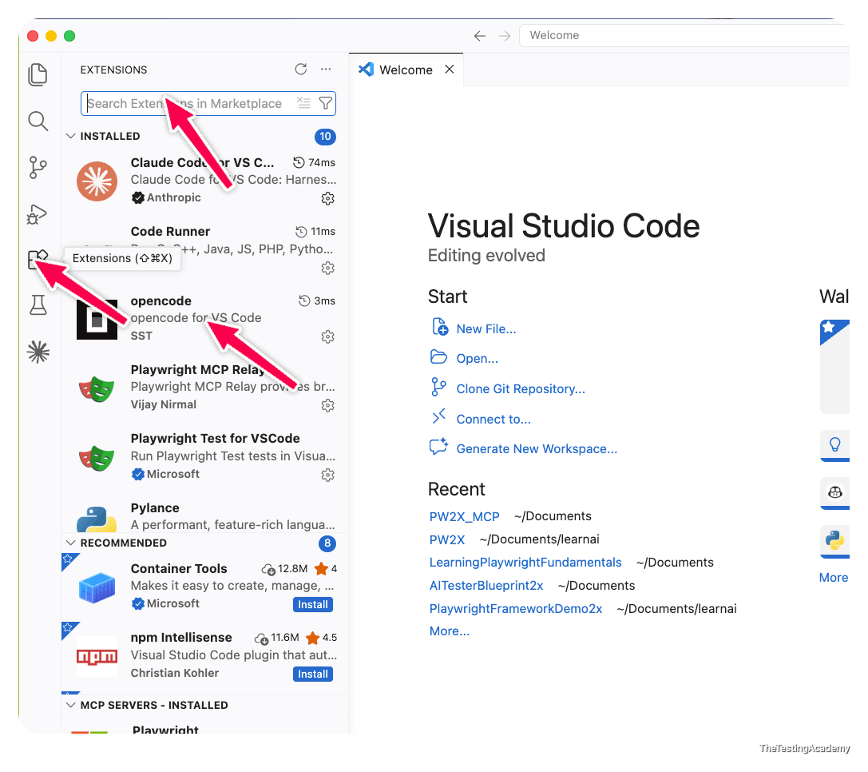
﻿
﻿

🟩 Install Google Antigravity
Disclaimer - Try to avoid to install in Company Laptop
﻿﻿antigravity.google/
﻿

﻿

How to set up the open code in Visual Studio Code?
- just install the Visual Studio Code, install the extension, and just log into your open code subscription
﻿﻿opencode.ai/go
You can buy the open code subscription, go for Rs 484 per month for the first month. Please rotate the email ID when it is required after the second month, which is there. You can use Deep Seek v4 Pro or Kimi K2.6 version, whichever both of them I use.
Install this extension into the Visual Studio Code, and you just have to log in to open code, and you are good to go.
﻿﻿marketplace.visualstudio.com/items?itemName=sst-dev.opencode
﻿
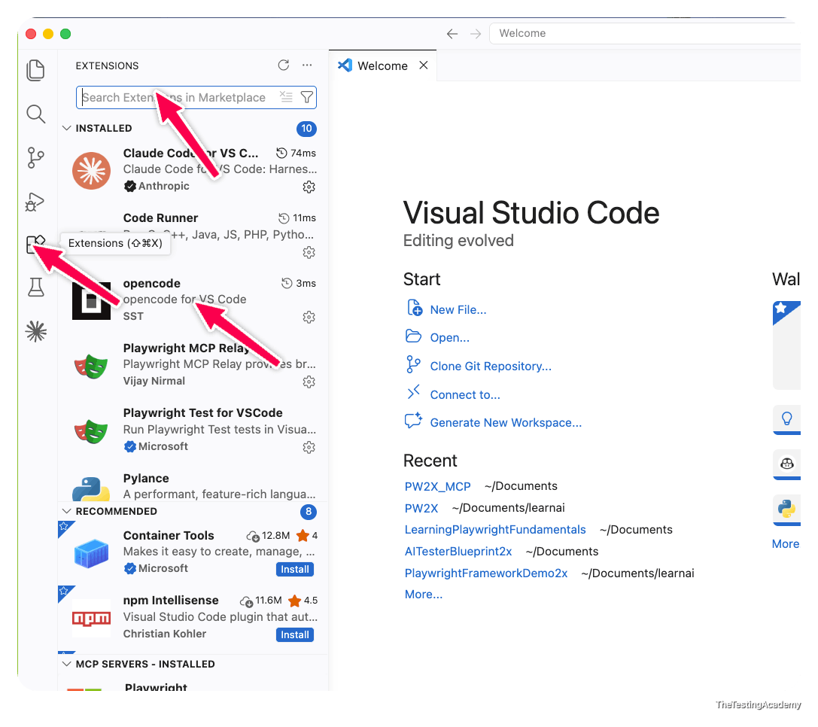
﻿

﻿

Install Node.js
﻿
Windows:
1. Download the Windows installer from the [Node.js website](https://nodejs.org/).
2. Run the installer.
﻿﻿nodejs.org/en/download
3. Follow the prompts in the installer (Accept the license agreement, click the NEXT button a bunch of times and finally install).
4. Restart your computer to ensure changes take effect.
﻿
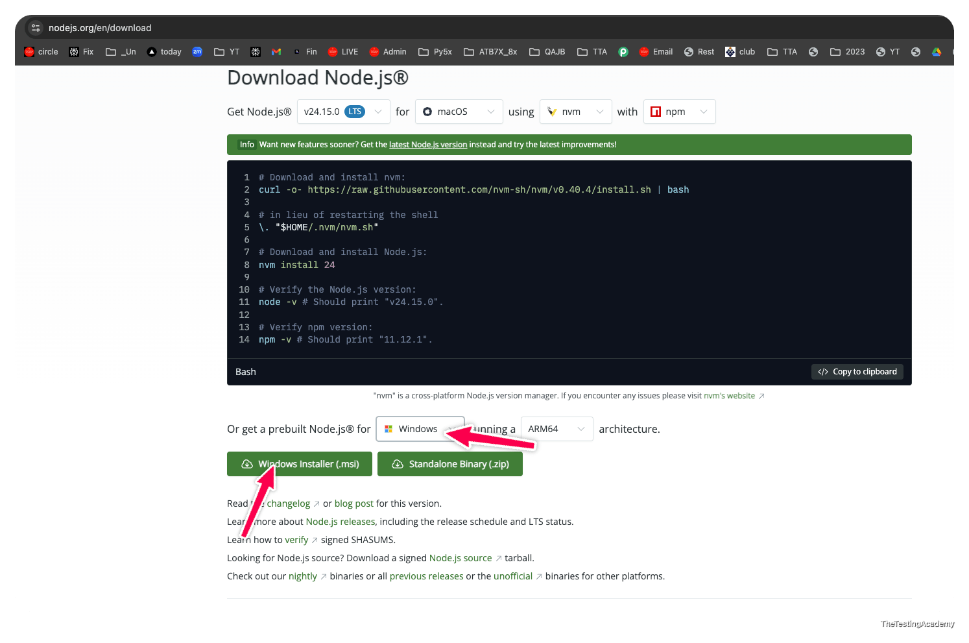
MacOS:
1. Download the macOS installer from the [Node.js website](https://nodejs.org/).
2. Open the `.pkg` file you downloaded and follow the instructions.
3. You may need to enter your admin password.
4. To verify installation, open a terminal and type `node -v`.
﻿
node --version
npm --version
Windows -> cmd
Mac /LINUX -> Terminal
﻿
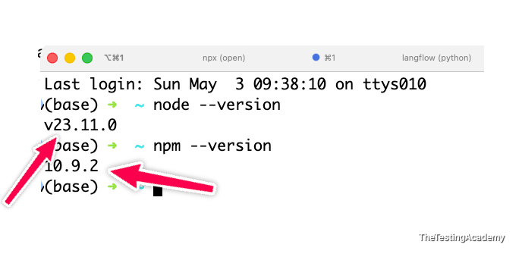
Task for the Today 4th May 2026
Task 1 - Install Visual Studio Code / Antigravity
Task 2 - Install the Node JS (verify)
Task 3 - Create the github.com/signup
﻿
Download Google Antogravity - ﻿antigravity.google/
Please install Google Anti-Gravity on your personal laptop if you don't want to use Visual Studio Code. Both Visual Studio Code and Anti-Gravity are the same
﻿

﻿

To run the JavaScript code
in the Visual Studio Code, we need the Code Runner extension
﻿﻿marketplace.visualstudio.com/items?itemName=formulahendry.code-runner
﻿
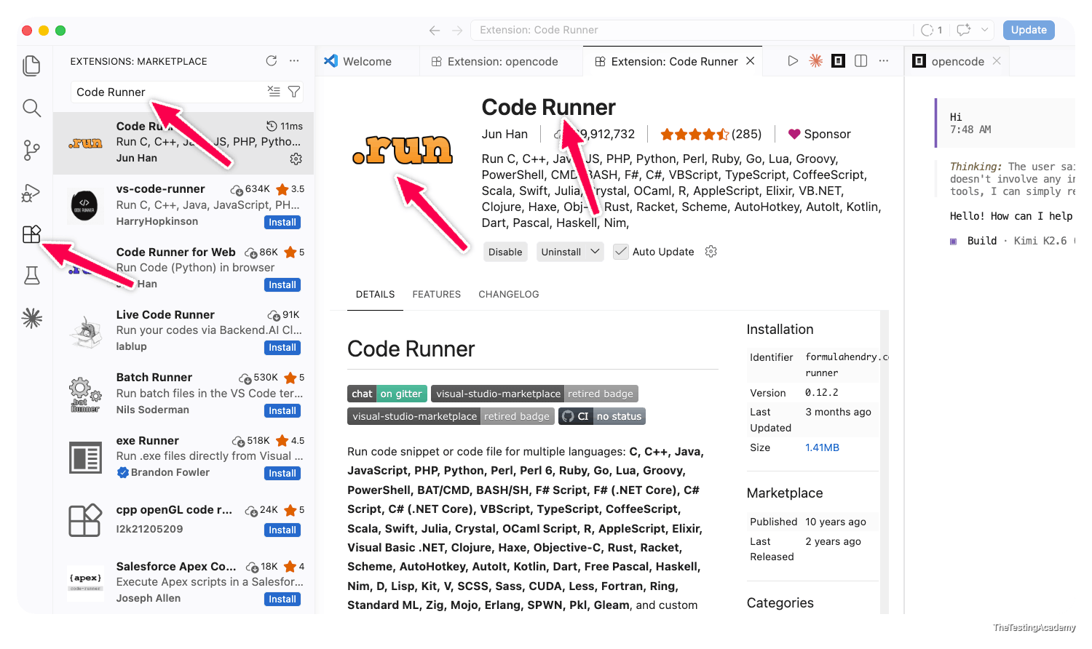

﻿
- Everyone should have access to the ﻿sdetclub.com -> Fill this form - to get access to the SDETCLUB - ﻿docs.google.com/forms/d/e/1FAIpQLSdr8F8m7jmIl6pdqezE0LZ8kphE2-ZpUTjBc9YxSBbsUjONaA/viewform
  - SDET Club we are using for the
    - Doubts
    - TASK
    - LIVE TEST
    - Notes
This is your own Private Group - ﻿www.sdetclub.com/c/playwright-2x/
﻿﻿docs.google.com/forms/d/e/1FAIpQLSdr8F8m7jmIl6pdqezE0LZ8kphE2-ZpUTjBc9YxSBbsUjONaA/viewform
﻿
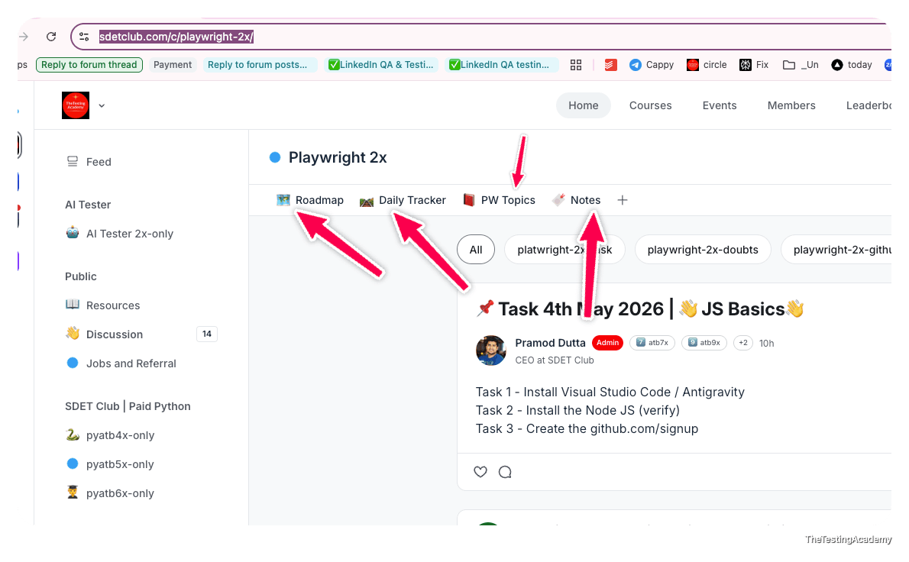
﻿

﻿

How to mark attendance?
- create a free account on this - ﻿app.thetestingacademy.com/student/my-process
- on today's date, you need to mention your title and topic, whatever you have learned, as well as if you have created your GitHub repository. Also mention that and click on Save Entry
﻿
﻿
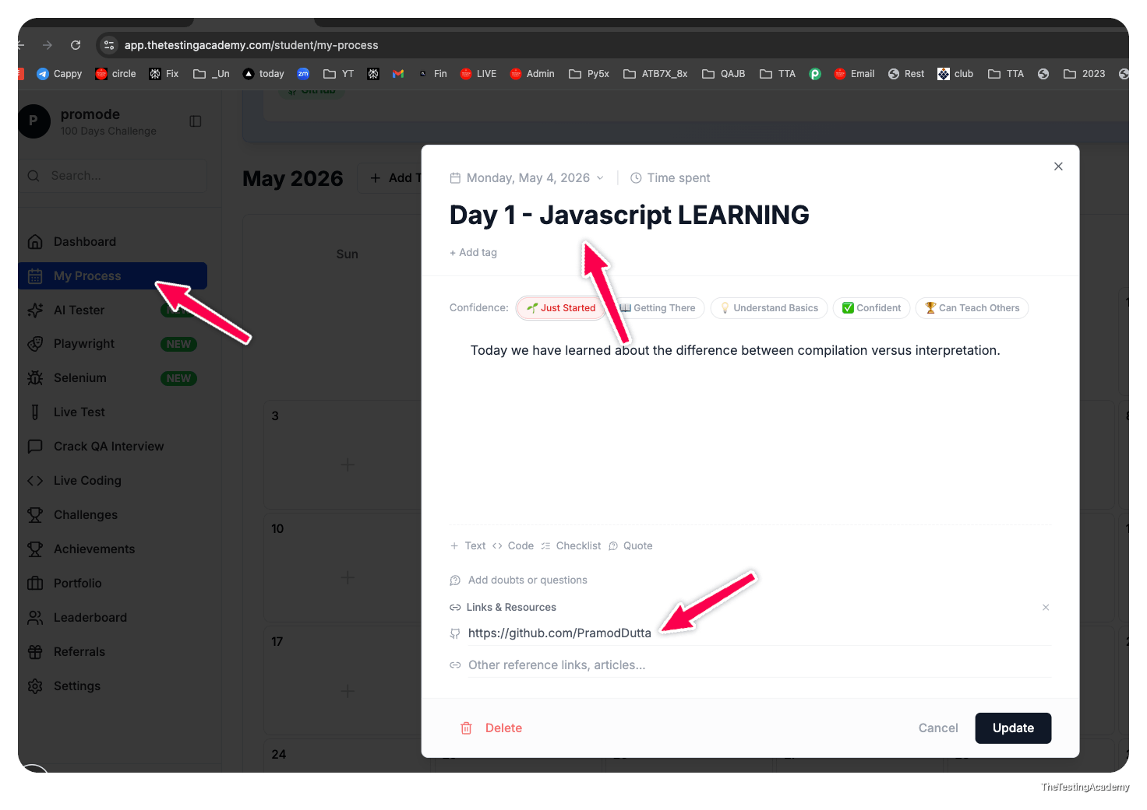

﻿
﻿

🟩 How JavaScript Engine Works
﻿
A JavaScript engine is a program that reads, interprets, and executes JavaScript code.
Here's a complete breakdown of how it works step by step.
﻿






